Nur Zahlen: **/^\d$/** Nur Buchstaben: **/^[a-zA-Z]+$/** *{int}$/ 🡪 Maximallänge*

Email : **/^\w+([-+.']\w+)*@\w+([-.]\w+)*\.\w+([-.]\w+)*$/**

Passwort (8 Zeichen Zahl & Buchstabe): **/ ^(?=.*[A-Za-z])(?=.*\d)[A-Za-z\d]{8,}$/**

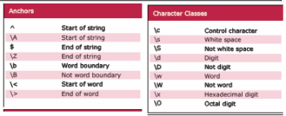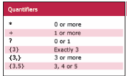

<Grid> 🡪 Grid.RowDefinitions 🡪 RowDefinitions

<Stackpanel> 🡪 Orientiation Horizontal, Vertical

<Canvas> Bottom Top Right Left

<DockPanel> DockPanel.Dock Left, Right, Top, Bottom !DockPanel.Dock = Mitte

<WrapPanel>

<ViewBox> Stretch: Fill, Uniform, UniformToFill

Element.Children.Add(Child) / Element.Children.Clear()

Margin: Left Top Right Bottom

MarkiereAlles: input.SelectionStart = 0; input.SelectionLength = input.text.length

isDefault = true 🡪 Enter. isCancel 🡪 Esc.

